a. Write a java code with the class named ‘acad’ and a method ‘main’. Hardcode the program with two integers and print the sum of those two.

public class acad{

public static void main(string [] args)

{int a=10,b=12;

Int sum=a+b;

System.out.println(sum);

}

}

**OUTPUT:**

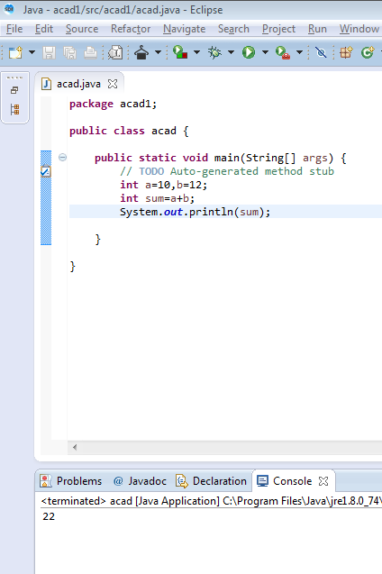

b. Rewrite the above code, where, inputs are provided by the user at runtime and the output is printed.

public class acad{

public static void main(string [] args)

{Scanner s=new Scanner(System.in);

int a=s.nextint();

int b=s.nextint();

int sum=a+b;

System.out.println(sum);

}

}

**OUTPUT:**

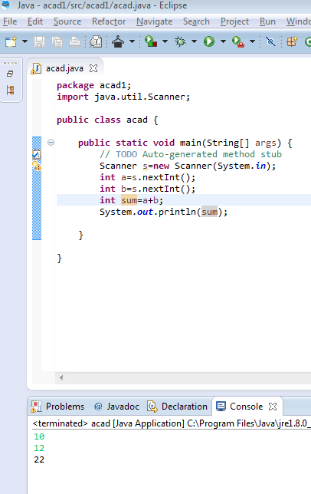

c.Write a program with method name sum() that accepts two parameters from user and print the sum two numbers. Output format should be as:

**First number is:**

**Second number is:**

**Sum is:**

public class acad {

public static void main{

Scanner s=new Scanner(System.in);

int a=s.nextInt();

int b=s.nextInt();

int sum=a+b;

System.out.println(“first number is: “+a);

System.out.println(“Second number is: “+b);

System.out.println(“Sum is: “+sum);}

public static void main(String[] args){

acad.a=new acad();

a.sum();}}

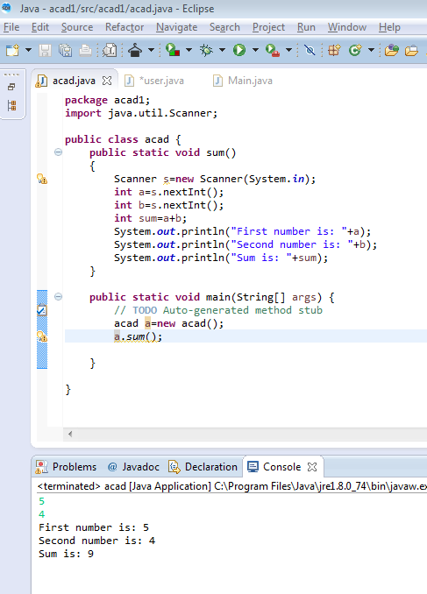

d.Write a program to accept two numbers from “stdin” and find all the odd as well as even numbers present in between them.

Import java.util.Scanner;

public class acad{

public static void main(String[] args){

Scanner s=new Scanner(System.in);

int a=s.nextInt();

int b=s.nextInt();

for(int i=a+1;i<b;i++){

System.out.println(i);}}}

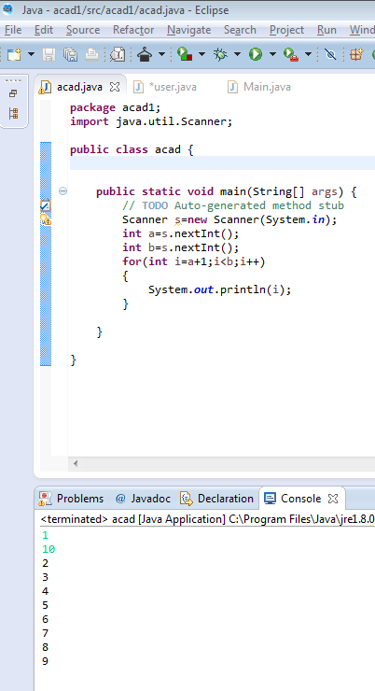

e.Joe is scared to go to school. When her dad asked for the reason, Joe said that she was unable to complete the task given to her by her teacher. The task was to find the “first 10 multiples” of the number entered from “stdin”.

Example:

Input: 3

O/P

3 x 1 = 3

3 x 2 = 6

………

………

…….

….

3 x 10 = 30

Help Joe in completing the task!

Import java.util.Scanner;

public class acad{

public static void main(String[] args){

Scanner s=new Scanner(System.in);

int a=s.nextInt();

for(int i=1;i<=10;i++){

System.out.println(a+”*”+i+”=”+a*i);

}

}

}

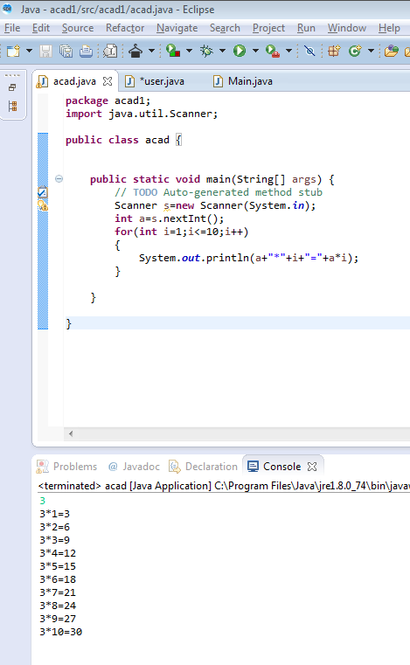

f.Write a program consisting the method “sum()” and demonstrate the concept of method overloading using this method.

import java.util.Scanner;

public class acad{

int sum(int n1,int n2){

return n1+n2;}

int sum(int n1,int n2,int n3){

return n1+n2+n3;}

public static void main(String[] args){

acad a=new acad();

System.out.println(“Sum of two numbers: “+a.sum(5,12));

System.out.println(“Sum of three numbers: “+a.sum(5,7,12));}}

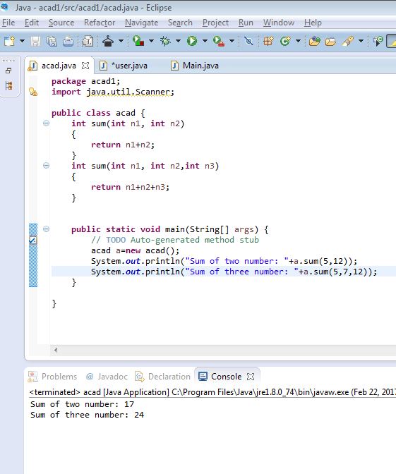

g.Can you overload a method with the same return type? Explain your answer with proper logic.

Yes, we can overload a method with the same return type.



In the above example, the two method sum() has same data type as int but the method sum() can be overloaded based on the number of arguments –We have two definition of method sum(), one with two arguments and another with three arguments.

h.Write a program in Java using Arrays that sorts the element in a descending order.

import java.util.Arrays;

import java.util.Scanner;

public class acad{

public static void main(String[] args){

Scanner s=new Scanner(System.in);

int a[]={1,5,4,7,6,8};

Arrays.sort(a);

for(int i=a.length-1;i>=0;i--){

System.out.println(a[i]);}}}

